**FALL TRAINING CONFERENCE 2017**

**Driving Directions**

Old Oak Ranch Conference Center

(15250 Old Oak Ranch Rd., Sonora, CA, 95370)

*TIPS:*

* **Please do not rely on your GPS.** It has been unreliable in many past experiences, since there will be **limited/no signal** in the campsite area and along the route (around Central California area)!
  + It is recommended that you pair these directions with a **set of printed directions** from Google Maps.
* Check out the route on Google Maps or your preferred navigation system to estimate your time of arrival and plan accordingly! You won’t want to miss out on **Opening Session at 9PM on Friday**!!
  + Don’t forget to consider the time it takes to pick everyone up for carpooling and potential traffic delays!
* If you have last-minute questions about directions, it will be best to **make calls at the Angels Camp area**.
  + Most individuals will lose cell phone service at the event site, and only a few providers will have limited service. This is usually the last area most people have solid cell phone reception before it starts to get spotty.

**From the Bay (~3 hours):**

* Head onto the 1-580 E
* Continue onto the I-250 E (14.61 mi)
* Merge onto the I-5N

**From Sacramento (~2 hours):**

* Head onto the I-5 S

**From Southern California (~6-8 hours):**

* Head onto the I-5 N

**General Directions from the I-5:**

1. Take exit 461 (from either I-5 N/S) to merge onto CA-120 E toward Manteca/Sonora

Drive 6.4 miles

1. Use the left lane to take the CA-99N/CA-120 exit toward Sacramento/Sonora N

Drive 1.7 miles

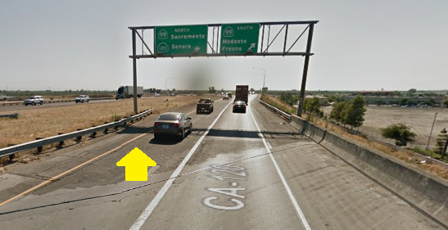 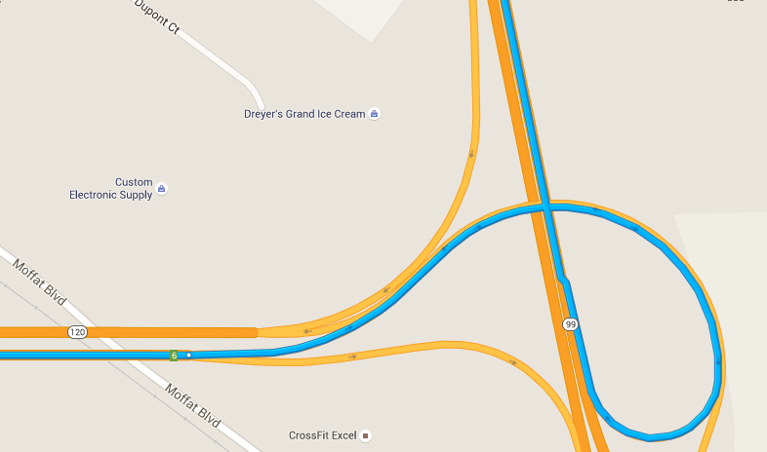

1. Use Right lane to take exit 242 for CA-120 E/Yosemite Ave towards Sonora

Drive 0.2 miles

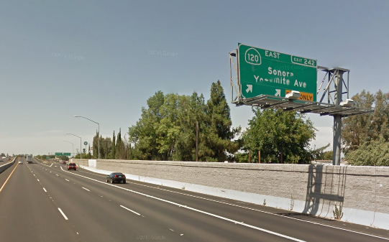 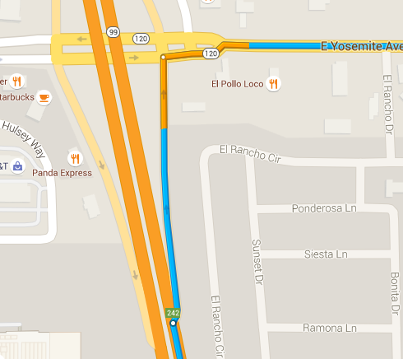

1. Turn right at CA-120E/E Yosemite Ave. and continue to follow CA-120 E

Drive 20 miles

1. Turn left at CA-108 E/East F St. if needed, prepare to stop for dinner!

Drive 0.4 miles

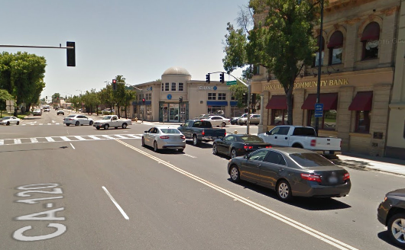 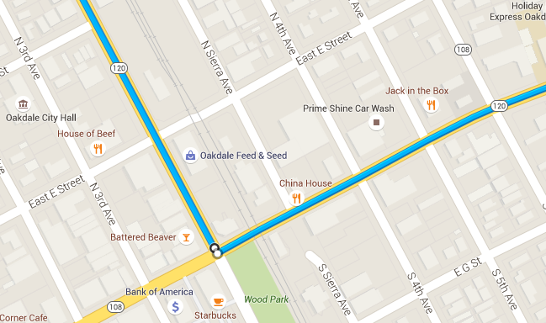

*Stop by Taco Bell (901 East F St. Oakdale, CA 95361), McDonalds (1322 East F St.), or Starbucks (1342 East F St.) if you are hungry and/or need something to drink!*

1. Head east on CA-108 E/East F St. towards N-8 Ave. and continue on CA-108 E

Drive 35.4 miles

1. Take the Hess Ave. exit

Drive 0.3 miles

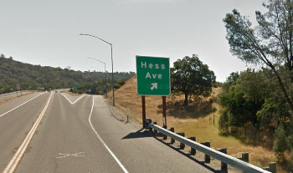 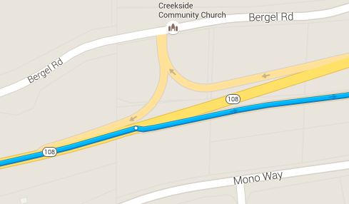

1. Turn left onto N Hess Ave. (under the highway) and drive 394 feet

Drive 0.4 miles

Then turn right onto Phoenix Lake Rd

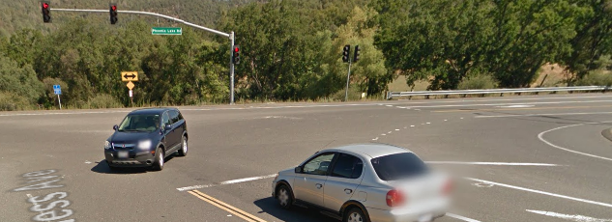 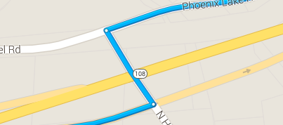

1. Stay on Phoenix Lake Rd

** This road curves often so check to see if you are still on Phoenix Lake Rd.

Drive 6.5 miles

1. Following a big curve to the left, Phoenix Lake Rd. will turn into Big Hill Rd

Drive 4.1 miles

Stay on Big Hill Rd

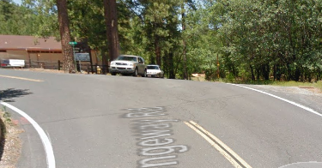 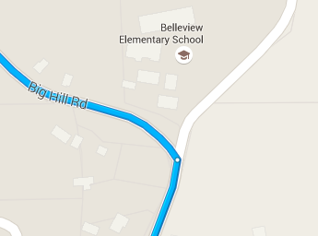

1. Make a sharp right onto Old Oak Ranch Rd

Drive ~2.0miles

**Old Oak Ranch Rd. is a very narrow two-way road, so watch out for other vehicles that might be coming your way!

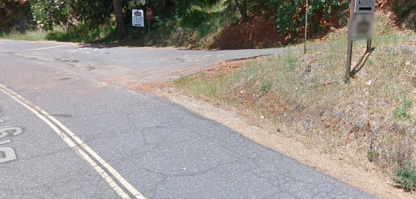 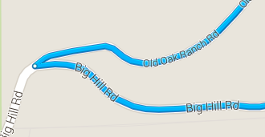

**Keep your eyes out for neon signs with the letters “FTC” once you arrive to Old Oak Ranch Road. They will guide you to the campsite**!

1. Turn right at the fork to stay on Old Oak Ranch Rd. and drive 0.4 miles. Make another right at the fork to stay on Old Oak Ranch Rd. and drive 0.6 miles

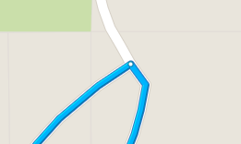

1. Drive through the main gates until you see the campsite. Park either along the road or at the parking lot at the end of the road - there will be traffic directors to guide you where to park.
2. You’ve made it safely to Fall Training Conference at Sonora, CA! Now please proceed to the lobby area of the main room (family center) for registration and the parking pass.

**Alternative Directions from Sacramento Area:**

1. From Sacramento, take the CA-16 E.
2. Take the CA-49 S (very obvious sign to lead you to this new road).
3. Stop in Angels Camp across the street from a shell if dinner break is needed – there is Subway, Starbucks, and McDonalds!
4. Continue south through Angels Camp and continue on the CA-49 S.
5. Continue past the lake and through Tuttletown until you reach a “T” in the road, then take a left to stay on the CA-49 S.
6. Your next turn will be a left onto Parrot’s Ferry Road. Look for signs for the “Columbia State Park” or “Columbia College” as you approach this turn. There will be a sign right before the turn you need to make with “Parrots Ferry Road” and “Columbia College” point left.
7. The next turn comes fairly fast as you will be turning onto Sawmill Flat Road, which can be easily missed since the road sign is on the left and very small. Look out for another “Columbia College” sign and turn right.
8. On Sawmill Flat Road, the only landmark you will pass will be Columbia College’s entrance, which is nearly the halfway point on the road. Once you pass the landmark, be on the lookout for Big Hill Road. It may be helpful to follow this path on an online map service (Google Maps) once you pass Columbia College to get an idea of where the turn comes.
9. The final turn is probably the hardest. The sign for “Old Oak Ranch” is an incredibly small reflective green highway sign. The turn will come as a veer left across the road.
10. Once you are on Old Oak Ranch Road, stay on the road and you will end up at the campsite!

**Alternative Directions for SoCal Schools:**

1. There is a shortcut through Merced that puts you about 20 miles east of Sonora rather than going all the way northwest to the 5/99 to head east on the 108/152!
2. Cheapest gas is located in Lost Hills and many stop for dinner in Kettleman City.

*See you all soon, and drive safe!!*